LAB REPORT # 10


Submitted by:

Submitted by:

Name | Registration No.
Muhammad Abdullah | FA24-BSE-042

Submitted to: Raheel Ahmed
Course: Digital Logic Design (EEE240)
Dated: MAR 8, 2026.

DEPARTMENT OF COMPUTER SCIENCE
COMSATS UNIVERSITY ISLAMABAD,
ISLAMABAD CAMPUS

Lab # 10

Digital magnitude comparator (2-bit comparator)

Circuit Daigram:
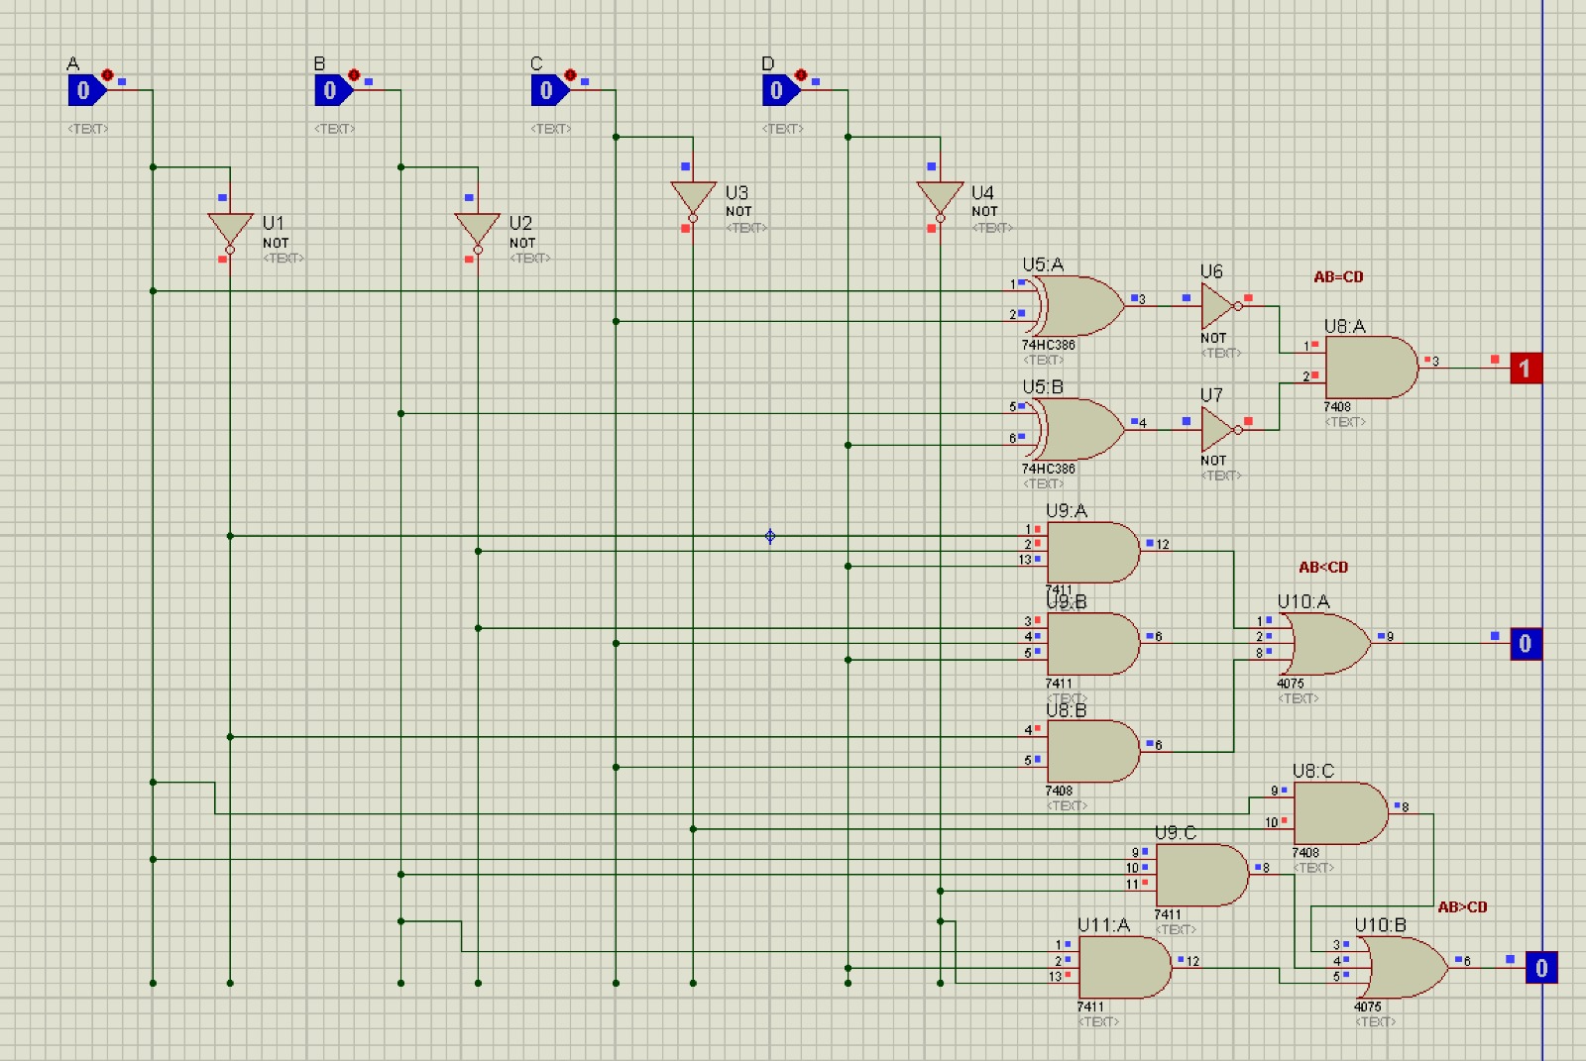
This circuit compares two 2-bit binary numbers:
First number = AB
Second number = CD
Outputs:
AB = CD → becomes 1 when both numbers are equal
AB < CD → becomes 1 when AB is smaller than CD
AB > CD → becomes 1 when AB is greater than CD

Truth Table:
A | B | C | D | AB=CD | AB<CD | AB>CD
0 | 0 | 0 | 0 | 1 | 0 | 0
0 | 0 | 0 | 1 | 0 | 1 | 0
0 | 0 | 1 | 0 | 0 | 1 | 0
0 | 0 | 1 | 1 | 0 | 1 | 0
0 | 1 | 0 | 0 | 0 | 0 | 1
0 | 1 | 0 | 1 | 1 | 0 | 0
0 | 1 | 1 | 0 | 0 | 1 | 0
0 | 1 | 1 | 1 | 0 | 1 | 0
1 | 0 | 0 | 0 | 0 | 0 | 1
1 | 0 | 0 | 1 | 0 | 0 | 1
1 | 0 | 1 | 0 | 1 | 0 | 0
1 | 0 | 1 | 1 | 0 | 1 | 0
1 | 1 | 0 | 0 | 0 | 0 | 1
1 | 1 | 0 | 1 | 0 | 0 | 1
1 | 1 | 1 | 0 | 0 | 0 | 1
1 | 1 | 1 | 1 | 1 | 0 | 0

Conclusion:
In this lab, we successfully designed and analyzed a 2-bit magnitude comparator using basic digital logic gates in Proteus. The main objective of the experiment was to compare two 2-bit binary numbers, represented by AB and CD, and determine whether the first number is equal to, greater than, or less than the second number. The circuit generated three different outputs: AB = CD, AB < CD, and AB > CD. Only one output became HIGH at a time depending on the comparison result.
During the implementation, we learned how different logic gates such as NOT, AND, OR, and XOR are combined to perform comparison operations in digital systems. We also understood the role of XOR gates in checking equality between bits and how multiple gate combinations are used to determine greater-than and less-than conditions. By applying all possible input combinations, we verified the working of the comparator through the truth table and confirmed that the circuit produced correct outputs for every case.
This lab improved our understanding of combinational logic circuits and binary number comparison techniques. It also helped us gain practical experience in circuit simulation, logic gate connections, and output verification in Proteus. Overall, the experiment demonstrated the importance of magnitude comparators in digital electronics and computer systems where comparison operations are frequently required.

